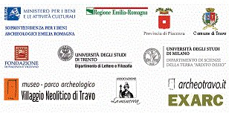  SYMPOSIUM  THIRTY YEARS  OF DIGS  AT TRAVO  THE LONG WAY OF ARCHAELOGY  IN THE TREBBIA VALLEY  VENUE: TRAVO, AUDITORIUM  FRIDAY, 7 JUNE & SATURDAY 8 JUNE 2013  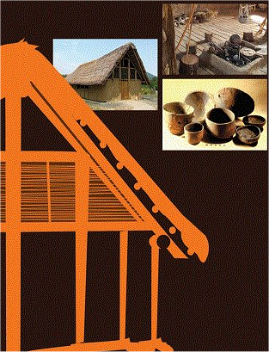 | FRIDAY 7 JUNE 2013  The Neolithic Site of Travo Sant’Andrea  10.00 Welcome address by Mr. E. Reggiani, Councillor for Cultural Affairs, Travo City Council and Opening of business  10.30 M. Berrnabò Brea, Authority for the Archaeological Patrimony, Emilia-Romagna Region. The Site of Travo Sant’Andrea: State of Works  10.50 L. Trombino, Milan University. The Geo-morphological and Palaeological Framework of the Site of Sant’Andrea  11.10 S. Pescio, Siena University. Micro-morpholigical and Geo-chemical Analysis of the Combustive Structures of Travo Sant’Andrea  11.30 A. Beeching, Lyon II University. Some Elements to Define the Cultural Connotation of Travo Sant’Andrea  12.00 M. Maffi, Travo Museum and Trento University. The Pottery Industry of Travo Sant’Andrea: Proposals for an Interpretation  12.30 Visit of the Park and Lunch Break  South-east France and North-west Italy between the Last Centuries of the V Millennium and the Middle of the IV Millennium b.C.  14.00 S. van Willigen, MMSH Lampea, Aix-en-Provence and Swiss national Museum, Zurich. The Chassean and the Other Middle-Neolithic Cultures in South-east France  14.30 A. Del Lucchese, Authority for the Archaeological Patrimony, Liguria Region. The late Neolithic Site of Genova Brignole  15.00 M. Maffi, Travo Museum and Trento University. The Site of Le Mose by Piacenza Between the Late and Recent Neolithic  15.30 L. Bemi, Antiquarium of Spilamberto. The Chassean Frequentation of Pascale: Digs by Malavolti  15.45 G. Steffé, Authority for the Archaeological Patrimony, Emilia-Romagna Region, L. Bemi and A.Ferrari, Antiquarium of Spilamberto, N. Dal Santo, Siena University. The End of Neolithic in Central-east Emilia  16.00 Break  16.15 D. Banchieri, Museum of Varese. The Isolino of Varese between the Late and Recent Neolithic  16.45 M. Baioni, Museum of Gavardo, and I. Tirabassi, City Museum of Reggio Emilia. The Neolithic Site of Levata by Curtatone (Mantua)  17.15 D. Castagna, SAP Archaeological Society , Mantua. The Pottery of Bagnolo San Vito (Mantua)  Discussion. Visit of the POSTER Section  SATURDAY 8 JUNE 2013  10.00 Welcome addresses by V.I.P.’s  F. M. Gambari, Superintendent  L. Albasi, Mayor of Travo  F. Scaravaggi, President, Piacenza and Vigevano Foundation  W. Tagliaferro, President, La Minerva Association  10.45 M. Berrnabò Brea, Authority for the Archaeological Patrimony, Emilia-Romagna Region. History of the Archaeological Digs in the Trebbia Valley  11.00 R. Conversi, Authority for the Archaeological Patrimony, Emilia-Romagna Region. Recent Salvage Interventions in the Archaeological Sites of Sant’Andrea and Santa Maria by Travo  11.30 M. Maffi, Travo Museum and Trento University. The Travo Archaeological Park and its European Developments  11.40 R. Paardekooper, EXARC, Director (NL). Archaeological Open-Air Museums in Europe  12.00 M. Parma, Counsellor for Cultural Affairs, Piacenza Province, and M. Libelli, “La Minerva Association”. The European Project “Grundtvig Senior”  12.30 Opening of the new facilities of the Travo Archaeological Park: red ribbon cutting by M. Mezzetti, Counsellor, Emilia-Romagna Region; M. Parma, Cousellor, Piacenza Province; F. Scaravaggi, President, Piacenza and Vigevano Foundation; and L. Albasi, Mayor of Travo  13;30 Reception  14;30 Visit of the Travo Archaeological Museum and Park and the digs currently in progress

